|  |  |
| --- | --- |
|  | Group G WDD Project Report Checkpoint 2 |
|  |  |
|  | Tristan Bradley Odhiambo  Web Design and Development (BSHCIFSC1)  11/23/25 |



Table of Contents

Group G 1

GitHub: 2

Ideas: 2

Colour palette idea 1: 2

Colour palette idea 2: 3

Site Map Version 2: 4

Possible visual appearance of the site (prototype): 4

Wireframes: 5

Tasks: 9

Notes: 10

|  |
| --- |
| Group G |
| Tristan Bradley Odhiambo  [x24236560@student.ncirl.ie](mailto:x24236560@student.ncirl.ie) |
| Alaxander Kirichenko  [x25780011@student.ncirl.ie](mailto:x25780011@student.ncirl.ie) |
| Derek O‘Kelly  [x24336050@student.ncirl.ie](mailto:x24336050@student.ncirl.ie) |
| Andrei Grigorita  [x24314820@student.ncirl.ie](mailto:x24314820@student.ncirl.ie) |

# GitHub:

|  |  |
| --- | --- |
| Derek O ‘Kelly | <https://github.com/dex9mm/Web-Design-and-Development-project> |
| Tristan Bradley Odhiambo | <https://github.com/DebugT/wdd_project_groupc> |
| Alaxander Kirichenko | <https://github.com/Sasha-Clover/myfirstwebsitenci> |
| Andrei Grigorita | <https://github.com/S1lverCr0w/wdd_group_proj> |

# Deployed Website:

|  |
| --- |
| <https://andrey-nci.byethost12.com/> |

# Ideas:

Colour palette idea 1:  
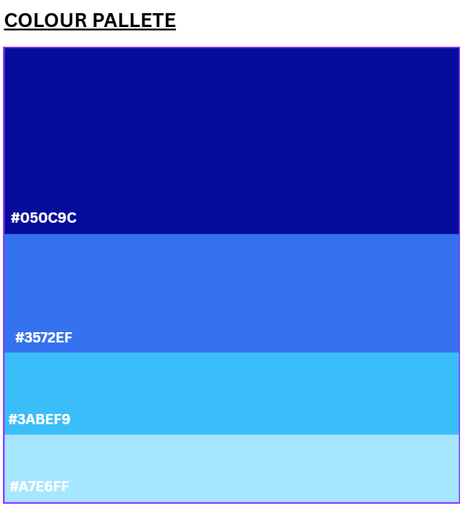  
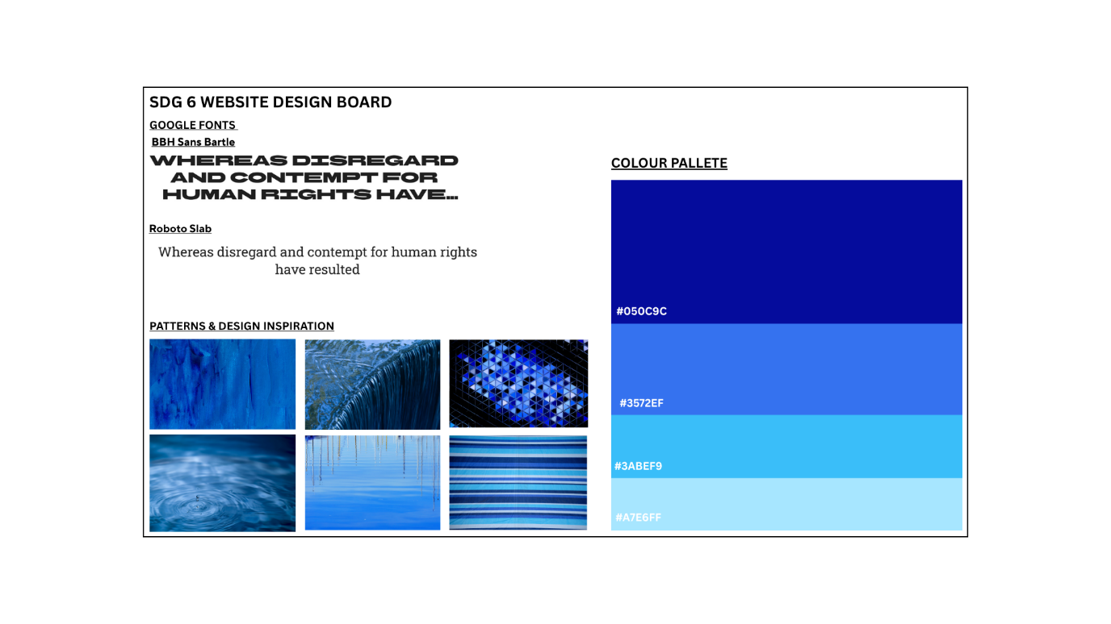

## Colour palette idea 2:

Alternate Colour palette idea below 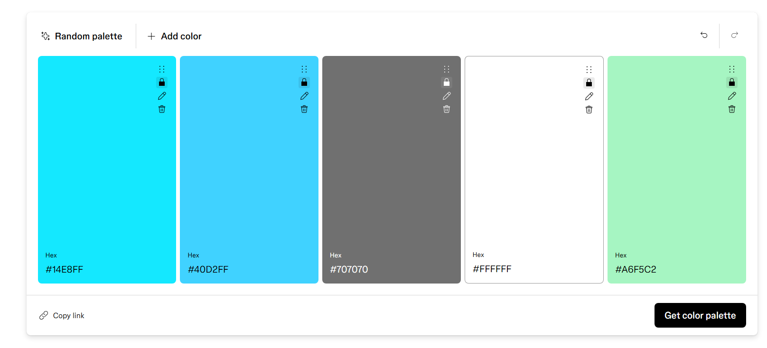

## Site Map:

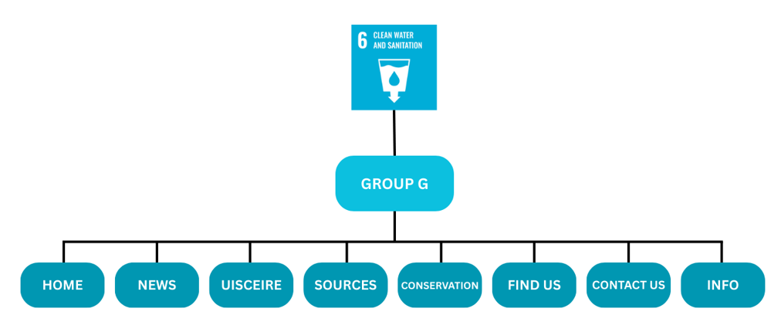

Possible visual appearance of the site (prototype):

MockUp1:

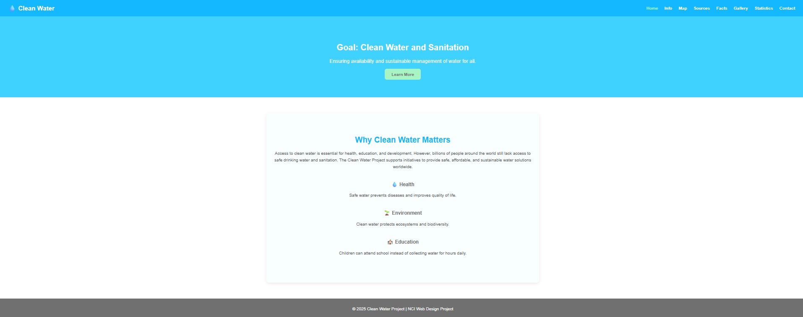

## Wireframes:

|  |  |
| --- | --- |
| Tristan |  |
| findus.html desktop | findus.html mobile |
|  |  |
| conservation.html desktop | conservation.html mobile |
|  |  |
| Alexander |  |
| contact.html desktop | contact.html mobile |
|  |  |
| info.html desktop | info.html mobile |
|  |  |

|  |  |
| --- | --- |
| Andrei |  |
| Index.html desktop | Index.html mobile |
|  |  |
| news.html desktop | news.html mobile |
|  |  |

|  |  |
| --- | --- |
| Derek |  |
| sources.html desktop | sources.html mobile |
|  |  |
| uisceIRE.html desktop | uisceIRE.html mobile |
|  |  |

# Testing:

|  |  |
| --- | --- |
| Index.html before/after | News.html before/after |
| after | after |
| Uisceire.html | Sources.html |
| After | After |
| Findus.html | Conservation.html |
|  | After |

|  |
| --- |
| Speed test |
|  |

# Tasks:

Andrei:

Page 1&2 :Landing page”s” (first 7 pages of pdf, broken between two pages)

Tristan:

Page 1: Info pages 8- 13 in pdf report on Irish water

Page 2: location, how to get to us address with google maps

Alexander:

Page 1: Contact us page (customer email/newsletter sign up, comment box ) ,

Page 2: info (who uses our water and for what?)

Derek:

Page 1: Report European water usage and where its needed the most

Page 2: Sources page: where all the information was gathered from

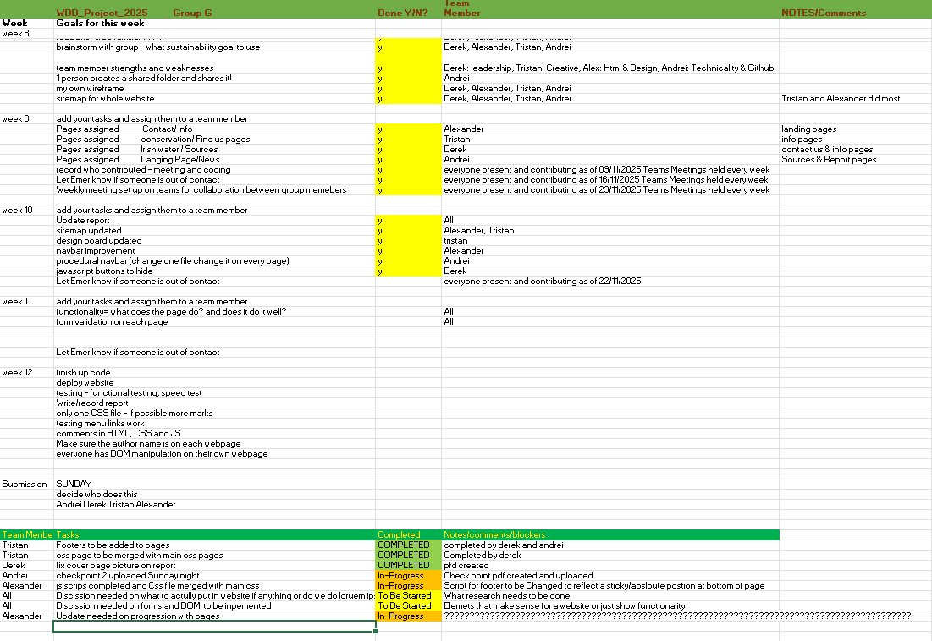  
  
U,{9a9b3f53-6eaf-46ac-b671-53f52700c505}{65},14.520833,5.125

# Notes:

* Everyone needs two pages no less
* One CSS file only
* Comment CSS to identify who made it
* Two wireframes per page each: desktop and mobile
* One sitemap per group
* [Colour palette:](https://www.figma.com/color-palette-generator/)
* GitHub commits have to be spread evenly

Grade Breakdown

Done

LEGENDè Must do

Critical

80-100%   
Excellent & above Excellent evidence of design process, consistent with final website. Very well documented.

Excellent project management demonstrated. Deliverables submitted on time.

Any feedback was clearly taken on board and incorporated to an excellent degree.

GitHub link showing ongoing regular commits over the project duration, has used gitbash or git Gui successfully.   
Excellent implementation of HTML elements, implemented excellently, working perfectly.

Demonstrates excellent advanced functionality.

Excellent use of CSS in a single file.    
Excellent use of JS in manipulation of the DOM & form validation.

Visually appealing and clear to users. With informative comments.   
Website is responsive with no visual errors using a responsive framework with extensive customisation. With informative comments.

Navigation fully working. Website deployed. Images optimised correctly.

Validator showing an excellent result.

Optimisation demonstrated via Google Page Speed rankings – excellent result. All excellently documented.